Product Requirement Document

E-business card Mobile application

|  |  |
| --- | --- |
| **Prepared by:** | Yagyani Tiwari |
| **Prepared for:** | Designer |
| **Current Version:** | V1.0 |
| **Ref No.:** | EBC/04012024 |
| **Document Name** | E-Business Card Mobile Phone |
| **Author:** | Yagyani Tiwari |
| **Date Created:** | 04th January 2024 |
| **Date Submitted:** | 04th January 2024 |
| **Approved By:** | Naman Narayan |
| **Approval Date:** | 00th January 2024 |

**Revision History:**  

|  |  |  |  |
| --- | --- | --- | --- |
| **Version Number** | **Brief Description of Changes** | **Revision Author** | **Date Updated** |
| V1.0 |  |  |  |
| V1.1 |  |  |  |
| V1.9 |  |  |  |

**Document Approvals History:**  

|  |  |  |  |
| --- | --- | --- | --- |
| **Version Number** | **Name** | **Signature** | **Date** |
| V1.0 | Naman Narayan |  |  |
|  |  |  |  |

Table of Contents

1. Introduction 2

2. Scope of work 2

2.1 Onboarding Page 3

Description 3

User story 3

UI Design 3

2.2 Signup Page 3

Description 3

User story 3

UI Design 4

2.3 Login 4

Description 4

User story 4

UI Design 4

2.3 Home page 5

# Introduction

The E-Business Card Creator is a mobile application designed to simplify the process of creating and managing electronic business cards. The app aims to provide users with a seamless onboarding experience and intuitive features for designing, sharing, and storing digital business cards.

# Scope of work

The scope of work includes following features :

* Onboarding page
* Signup page
* Login page
* Home page
* Business card Menu
* Account Menu
* Contract menu
* Profile
* Scan QR code
* Chat

## Onboarding Page

### Description

This page contains the welcome screen of the mobile application which will be visible at the start of the application. There should be a welcome text given to welcome users to the platform. The signup button is also visible to redirect user to the registration page.

### User story

I as a user

* Will open the app and can see the onboarding screen.
* Can see the welcome text given on that screen.
* Can see a signup button too so that I can register myself on the app.

### UI Design

Attached is the example image for the onboarding screen.

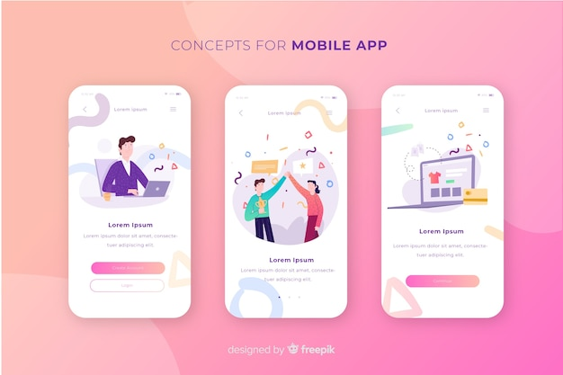

## 2.2 Signup Page

### Description

This section will contain the registration form and the option to complete the registration using email, google, Facebook and phone number.

### User story

I as a user

* Can see the registration form.
* Can register myself using my google account.
* Can register myself using a Facebook account.
* Can register myself using a phone number.

### UI Design

Attached image is an example for the UI design.

## 2.3 Login

### Description

From this page users can enter inside the platform using their username and password, google account, Facebook account, phone number. This page will have the username and password field, login button to enter the details and enter inside the platform.

### User story

I as a user,

* Can login into the platform using the username and password.
* Can login into the platform using the google account.
* Can login into the platform using my Facebook account.
* Can login onto the platform using the phone number.

### UI Design

Attached is the example image for the login page.

## 2.3 Home page

Description

In this page user can see all the available templates which user can update according to their need if they want to update.

User story

UI Design